Project Report

**Introduction :**

Empathy map , Brainstroming map and designed a certificate using canva.

**Purpose :**

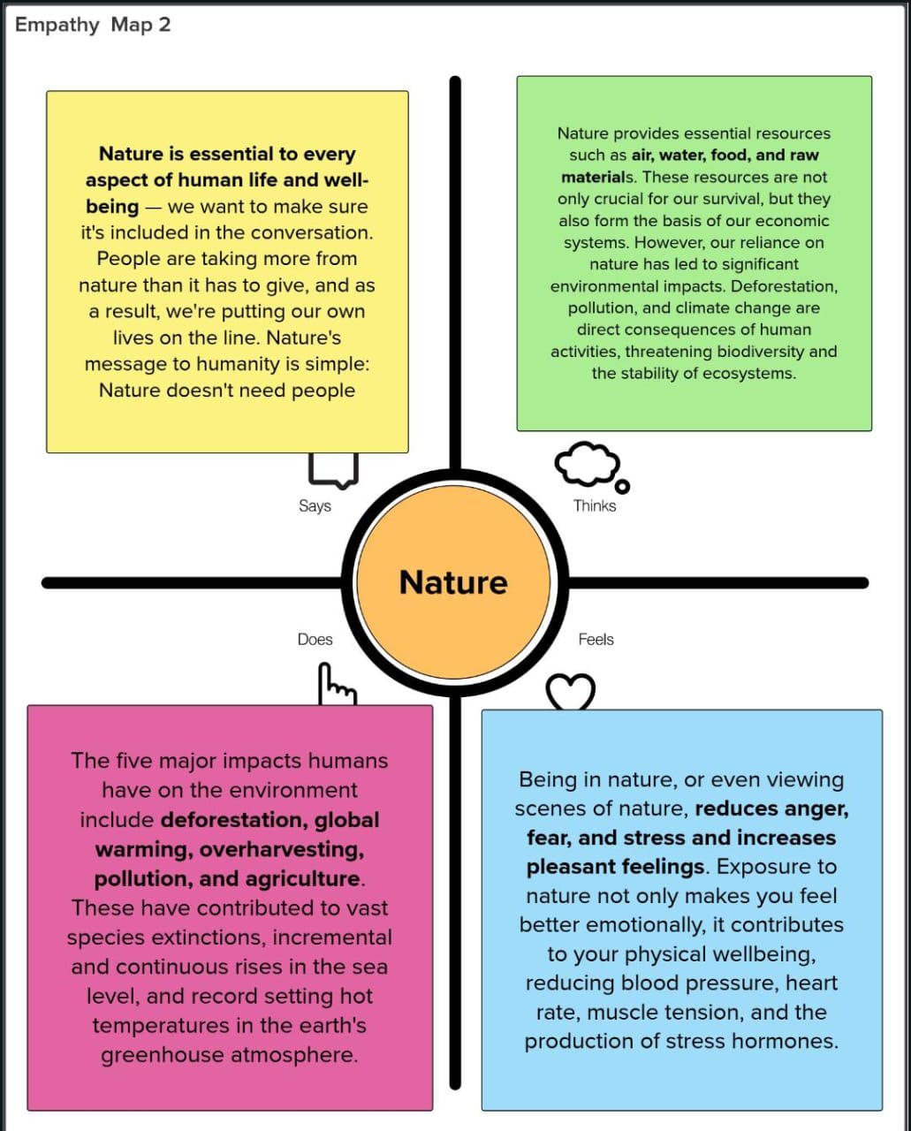 To create awareness in the society.

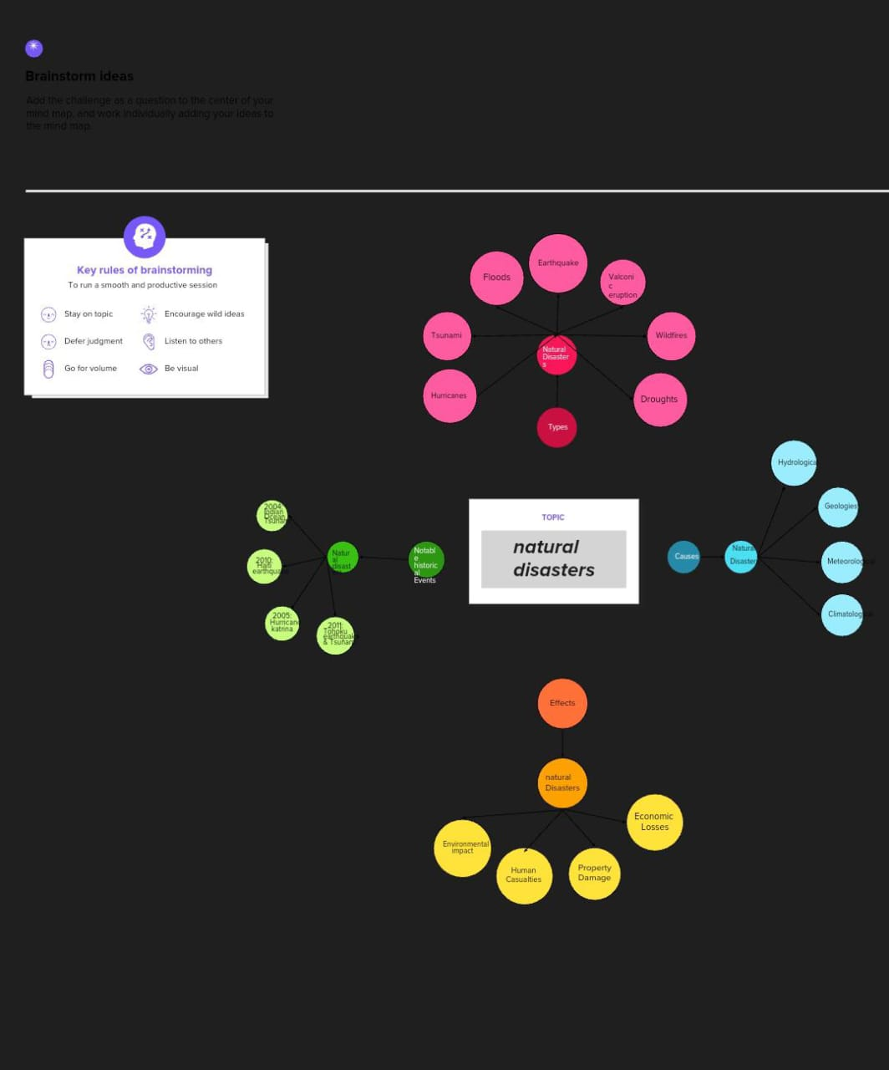 **Problem definition and Design:**

Empathy map Brainstroming map

**Result:**

**Design a certificate with canva.**

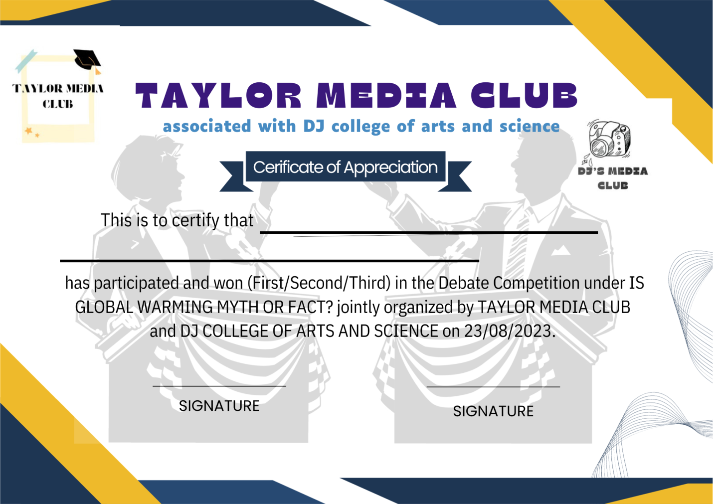

**Advantages and Disadvantages :**

* Awareness about the Nature and Natural disaster is conveyed is the advantage.
* It is a certificate for a competition conducted in a college so the awareness is only given to the college students.It is the disadvantage.

**Applications:**

My design in canva app is Designing a certificate. My project is focusing in Global warming which is most important thing to care about. This design is to create awareness about Global warming in the college level students by conducting Debate competition.

**Conclusion:**

From this NAANMUDHALVAN course I have learned may things using CANVA . I’m so thankful for our Government and our CM Mr. M.K.Stalin for giving us this oppurtunities.